Max Shi

Professor de Rosa

E 234

September 30, 2020

I pledge my honor that I have abided by the Stevens Honor System.

Partner: Ashley McDermott

Homework 3

1a. vf = 0.0007697 + 0.0007771 / 2 = 0.0007734 m3/kg

vg = 0.072434 + 0.063681 / 2 = 0.0680575 m3/kg

vfg = 0.0680575 – 0.0007734 = 0.0672841 m3/kg

V = 14 L = 0.014 m3

v = 0.014/10 = 0.0014 m3/kg

x = (0.0014 – 0.0007734) / 0.0672841 = 0.0093

**T = -1.25 + 2.46 / 2 = 0.605°C**

hf = 50.16 + 55.14 / 2 = 52.65 kJ/kg

hg = 249.77 + 251.93 / 2 = 250.85 kJ/kg

hfg = 250.85 – 52.65 = 198.2

**h = 52.65 + 198.2*0.0093 = 54.49 kJ/kg**

­­1b. vfg = 0.034335 – 0.0008198 = 0.0335152 m3/kg

x = (0.0014 – 0.0008198) / 0.0335152 = 0.0173

**T = 21.55°C**

**h = 81.50 + 180.95*0.0173 = 84.63 kJ/kg**

1c.

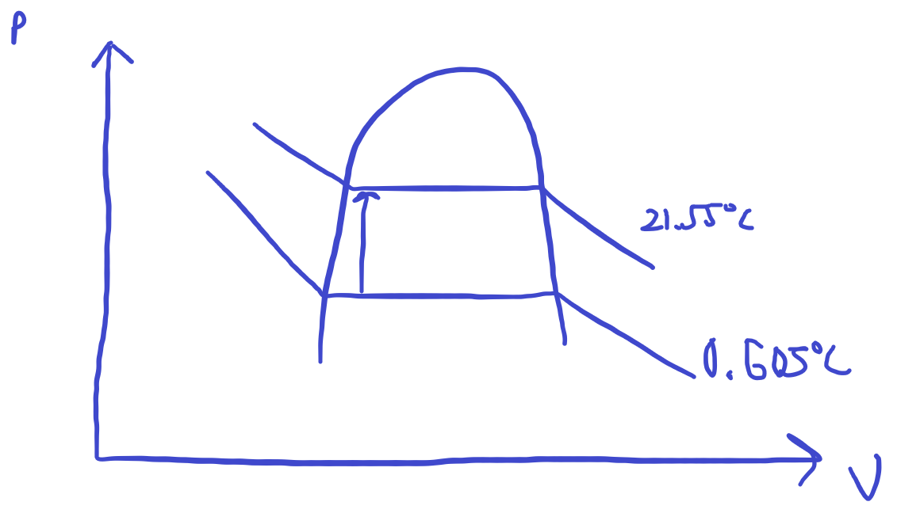

2a.

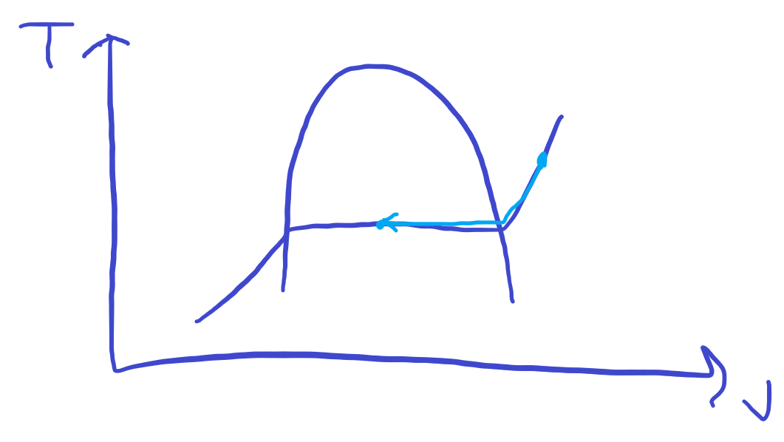

2b. **Final temperature is 151.83°C**

2c. Specific volume for superheated water at 200**°C is 0.42503** m3/kg.

Volume of the superheated water is 0.42503 * 0.6 = 0.255 m3

Specific volume for the mixture (x=0.5) is 0.001093 + 0.5(0.37483 – 0.001093) = 0.1880 m3/kg

Volume of the mixture is 0.113 m3, which means the change in volume is 0.142 m3.

3. Water vapor cannot be treated as an ideal gas because it is not a gas at room temperature. Furthermore, the polarity of water causes intramolecular forces to interact between water molecules, especially at lower temperatures, violating the rules of ideal gases.

4.

$$PV=mRT \\ \left(20+14.6\right)\left(0.53\right)=m\left(0.3704\right)\left(90+459.67\right) \\ 34.6*0.53=m\left(203.60\right) \\ m=0.090 lbm \\ \frac{P_{1}}{m_{1}}=\frac{TR}{V}=\frac{P_{2}}{m_{2}} \\ \frac{34.6}{0.090}=\frac{44.6}{m_{2}} \\ m_{2}=44.6*\frac{0.090}{34.6}=0.116 \\ m_{2}-m_{1}=0.116-0.090=0.026 lbm air$$ 5a.

$$PV=mRT \\ v=\frac{V}{m}=\frac{RT}{P} \\ R=\frac{R_{u}}{M}=\frac{8.314}{18.01}=0.4615 \\ v=\frac{0.4615*\left(350+273.15\right)}{15000}=0.01917 m^{3}/kg$$ 5b.

$$P_{critical}=22060 kPa \\ T_{critical}=647.096 K \\ P_{R}=\frac{P}{P_{critical}}=\frac{15000}{22060}=0.6800 \\ T_{R}=\frac{T}{T_{critical}}=\frac{350+273.15}{647.096}=0.963 \\ Z=0.7 \\ v=\frac{ZRT}{P}=\frac{0.7*0.4615*\left(350+273.15\right)}{15000}=0.01342{ m}^{3}/kg$$ 5c. From the table: v = 0.011481 m3/kg.

6. Volume of second tank:

$$PV=mRT \\ 200V=5*0.2870*\left(35+273.15\right) \\ V=2.21 m^{3}$$

Mass of air in first tank:

$$PV=mRT \\ 500\left(1\right)=m\left(0.287\right)\left(25+273.15\right) \\ m=5.843 kg$$ Final pressure:

7. No because in order to compress an ideal gas, work needs to be put into the system. According to the law of conservation of energy:

$$∆E=E_{in}-E_{out} \\ ∆\left(U+KE+PE\right)=Q+W$$ KE and PE are 0, and because the process is isothermal, U is also 0. Because the piston cylinder is adiabatic, Q must also be 0. This leaves us with: $$0=W$$ However, to compress the system, work must be put in. Therefore, W cannot be zero and this presents a contradiction, which means that it is impossible to compress an ideal gas isothermally in an adiabatic piston-cylinder device.

8.

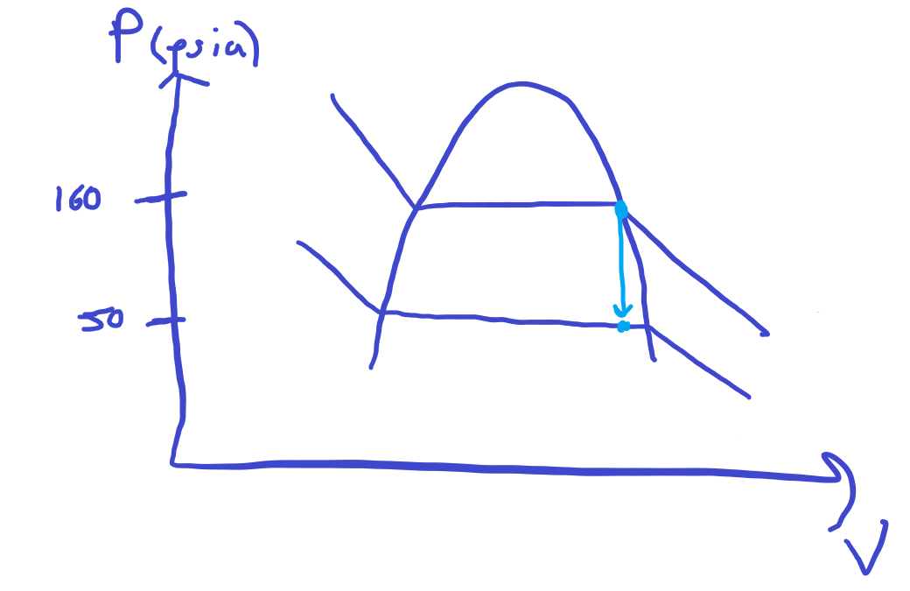

8a.   
Specific volume of saturated vapor at 160 psia: 0.29339 ft3/lbm = constant specific volume of our gas  
Specific volume of saturated vapor at 50 psia: 0.94909 ft3/lbm  
Specific volume of saturated liquid at 50 psia: 0.01252 ft3/lbm

Because our specific volume is still between these two values at 50 psia, it is still a mixture, and therefore the temperature is **sat. temp = 40.23°F**

8b. Mass of gas = 20 ft3 / 0.29339 ft3/lbm = 68.169 lbm  
Quality = $\frac{0.29339-0.01252}{(0.94909-0.01252)}=0.300$  
**Amount condensed = mass * (1-quality) = 47.72 lbm**

8c.

$$∆E=E_{in}-E_{out} \\ ∆U=∆Q=m\left(u_{2}-u_{1}\right) \\ u_{1}=108.51\frac{Btu}{lbm} \\ u_{2}=24.824+0.3\left(75.228\right)=47.3924\frac{Btu}{lbm} \\ ∆Q=∆U=68.169\left(47.3924-108.51\right)=-4166 Btu heat transfer$$